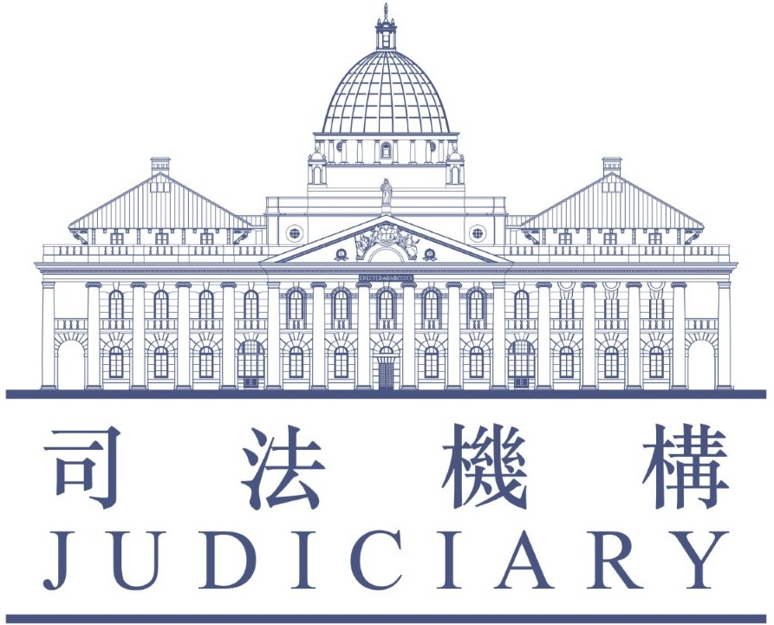
Entry Form
List of Accredited Mediators for the
Building Management Mediation Co-ordinator's Office

PART I - PERSONAL PARTICULARS
1.1 Name (English): (Surname) Mr./Mrs./Miss/Ms*
(Other names) (in full)
(Chinese):
1.2 Hong Kong Identity Card/Passport No.*:
1.3 Profession (Please choose only one box)  Architect
 Barrister-at-law
 Counsellor
 Engineer
 Property Management Officer
 Psychologist
 Social Worker
 Solicitor
 Surveyor
 Therapist
 Others (please specify: )

1.4 Name of Employer (if any) (English):
(Chinese):
1.5 Position in Organization (English):
(Chinese):
1.6 Correspondence Address (English):
(Chinese):
1.7 Telephone No.: (Office) (Mobile)
1.8 Fax No.:
1.9 Email Address:
1.10 Academic Qualification (Institutes and year obtained):

PART II – RELEVANT EXPERIENCE AND INFORMATION

2.1 Details of Accreditation in the Hong Kong Mediation Accreditation Association Limited (“HKMAAL”):

(please attach certificate from HKMAAL and note item 4.4)

(i) Date obtained (Month/Year): / .

(ii) Practising mediation since (Month/Year): / .

(iii) Approximate no. of mediation cases handled in the past 3 years

case(s)

2.2 Relevant Experience in the Fields of Law or Mediation:
(If there is insufficient space, please give details on a separate sheet to be attached to the Entry Form.)
Date | Name of Organization | Type of Work

2.3 Mediation Service Offered and Venue for Mediation:

(i) Fees Charging:

(You may choose more than one box)

 Pro bono service for case(s), subject to a maximum of 15 hours per case.

(Mediators may consider extending the number of hour if it would facilitate an agreement between parties concerned, as and when appropriate)

 Fee-charging service at an hourly rate of HK$ .

 Others (Please specify)

- Venue for Mediation Appointments:
(Please choose only one box)

 I will provide mediation venue as follow:

Chinese:
English:
Office hours:  Weekdays
 Office Hours
 Non Office Hours
 Saturday
 Sunday
 Public Holidays
(You may choose more than one box)
(N.B.: Office hours denote normal working hours
(i.e. 9am. - 6pm.))

 I will not provide mediation venue

Available to provide Online Mediation:

(Please choose only one box)

 Yes
 No

2.4 Language and Dialect Proficiency:

- I have the skills and expertise in the following language/dialect:

(You may choose more than one box)

 English  Cantonese  Putonghua

 Others (Please specify)

- I have the skills and expertise in drafting documents in:

(You may choose more than one box)

 English  Chinese

 Others (Please specify)

PART III – PROFILE SUMMARY
Name (Mr./Mrs./Miss/Ms*)
姓名 (先生/太太/小姐/女士*)
Profession
專業
Name of Accreditation Body  調解員資格認可機構 |  | Hong Kong Mediation Accreditation Association Limited  香港調解資歷評審協會
Year of Accreditation
取得調解員資格年份
Practising Mediation since
從事調解工作自
No. of Mediation Cases Handled In The Past 3 Years
過去三年處理調解個案數目
Language /  Dialect Proficiency  語言能力 | Spoken 交談
 | Written書寫
Pro Bono /
Mediation Fee To Be Charged
免費 / 調解費用
Venue for Mediation Appointment
調解會面地址
Time for Mediation Appointment
調解會面時間
Telephone No.  電話 |  | (Office):  (Mobile):
Fax. No.
傳真

PART IV - DECLARATION

4.1 I declare that the information provided in this Entry Form is accurate to the best of my knowledge and belief.

4.2 I understand that the information provided on this Entry Form namely, the mediator’s name, profession, name of accreditation body, year of accreditation, the year commencing practising mediation, no. of mediation cases handled in the past 3 years, language/dialect proficiency (spoken and written), pro bono/mediation fee to be charged, venue and time for mediation appointment, telephone and fax number may be included in the List of Accredited Mediators at the discretion of the Building Management Mediation Co-ordinator’s Office (“BMMCO”) and may be accessible to members of the public upon enquiry.

4.3 I agree to notify the Mediation Co-ordinator as soon as possible:
- if there is any change in the information provided in this Entry Form; and
- if I am not available to take on any mediation work for a period of 4 weeks or more.

4.4 I undertake to notify the Mediation Co-ordinator if I cease to be Accredited Mediator/member of HKMAAL.

4.5 I undertake to abide by the following terms if I receive cases which have attended Information Sessions and/or Pre-mediation Consultation at BMMCO:
- to comply with the mediation Rules and relevant Guidelines of HKMAAL and the Hong Kong Mediation Code; and
- to provide mediation case statistics and data as required by BMMCO for the purposes of evaluation of mediation service of the Office.
4.6 I apply to have my name included on the List of Accredited Mediators. I also agree to the access of the Mediation Co-ordinator to my personal data kept in HKMAAL.

Date: Signature:

Note:

- Please submit the Entry Form (Part I, II & III in MS Word format), with scanned Part IV and Certificate of Accreditation Body to Building Management Mediation Co-ordinator’s Office by email at bmmco@judiciary.hk. Alternatively, you may submit the completed Entry Form with a copy of Certificate of HKMAAL by fax or by post:

Address: Room 206 - 208, 2/F,
Lands Tribunal Building,
38 Gascoigne Road,
Kowloon

Fax: 2782 5780

- Applicants are advised to provide all the information requested in the relevant documents, where applicable, failing which the Mediation Co-ordinator may refuse to process and consider their applications.
- The Mediation Co-ordinator reserves the right to require further information or proof as to the information provided.
- For enquiries concerning submission of this Entry Form, please contact Mediation Co-ordinator at 2170 3858.

PART V – STATEMENT OF COLLECTION

Purpose of Collection

5.1 The personal data provided in this form will be used:-
- for arranging mediation service; and
- for the purposes of enabling the Mediation Co-ordinator to discharge her duties and functions under the Building Management Mediation Co-ordinator’s Office and may be accessible to members of the public upon enquiry.

5.2 The provision of personal data by you is voluntary. If you do not provide sufficient information, the Mediation Co-ordinator may not be able to process your application for your name to be included on the List of Accredited Mediators.

Classes of Transferees

5.3 The personal data you provide on this form may be disclosed to the public, government departments or other relevant parties for the purposes stated in paragraph 5.1 above.

Access and Correction of Personal Data

5.4 You have a right of access and correction with respect to your personal data as provided for in Sections 18 and 22 and Principle 6 of Schedule 1 of the Personal Data (Privacy) Ordinance (Cap. 486). Your right of access includes the right to obtain a copy of your personal data provided by this form upon payment of a prescribed fee.

Enquiries

5.5 Enquiries concerning the personal data collected by means of this form, including the making of request for access and correction, should be addressed to:

Mediation Co-ordinator

Building Management Mediation Co-ordinator’s Office

Room 206 - 208, 2/F,

Lands Tribunal Building,
38 Gascoigne Road,

Kowloon

Tel.: 2170 3858

* Please delete as appropriate
* Please delete as appropriate

